MJNUTES OF THE MEETING

Of THE

AUSTRALIA AND NEW ZEALAND ASSOCIATION

FOR

CLINICAL PASTORAL EDUCATION

Executive Committee
HELD IN ST11fOMAS A/ORE JUNIOR COMMON ROO/lf ON
muRSDAY JUNE 11, 1993 ATJ.30PM

Attendance : The Rev'ds D. Buchanan, J. Peterkin, D. Stark, D. LeJean and K. Little.

Review Committee Report:

The report on the Rev'd Da\-id Larsen's re-accreditation was received and unanimously endorsed.

The Rev'd David Larsen then joined the meeting.

Minutes: TI1e minutes of the Executive Committee meeting on June 23, 1992 were read and confirmed.

General Business:

The committee spent some tinle discussing the need for guidelines for Chairper­ sons who are reporting to the Executive Committee and Member Organisations on Review Committees. Such guidelines were needed for the protection of the applicant and the process .

Closw-e: The meeting cJosed at 1.55 pm.
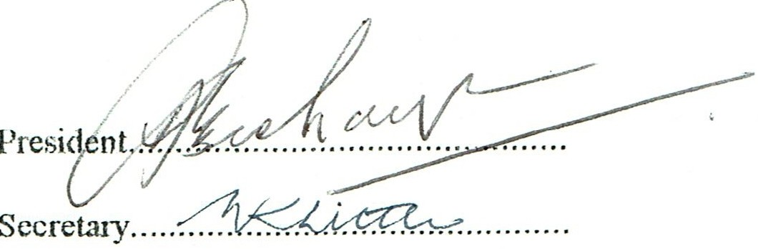

Date................................... .

Minutes of the meeting of the Management Committee

of the
AUSTRALIA AND NEW ZEALAND ASSOCIATION FOR CLINICAL PASTORAL EDUCATION.
held in the Co11fere11ce Room, Franciscan Life Centre, Coorparoo,
Quee11s/a11d 011 Saturday .lune 18, 1994 at 2.30pm.

Altcnda ncc :

Apologies:
D. Buch:111an (Pres ide n t). J Pe terkin. J. O'Brien . C Francis, A. Jel ly. R. Ale xande r, D. Olafsen. B. Glassy , D. Lelca n. M. Lee. D. Larsen. J. Reed y. M. Coleman and K. Little.

- Brooke. B. Kem pe. D. Stark and B. Ha le.

It was resolYed :

M94/ I. Tlwt these be the apologies

The Rev'd Da,·id Stark:

The President reminded the mem bers that David had this morning had a coronary
by-pass operation and asked Drew Lelcan to report the lates t info rmation . He reported that David had been given three by-passes and that the operation had been successful.

Ms Bev Collier:

The meeting ,ms informed that she had die d on Wednesday June I 5. 19 94. Judy Peter­ kin. Julie O'Brien Cecilia Francis and other members spoke warml y and sensitively about her life and contribution to ministry and those who kne,Y her.

Membership Fees:

The Treasurer reported that all membership fees had been paid for the current year.

Hours of Sessi011:

H ·i, as reso lved :

M94/2. That the meeting adjourn at 3.30 pm.

Introductions and Reports:
The President ask each member to introduce themselves and report on their journey.

Adjournment: The meeting adjourned for a!lernoon tea.

Hours of Session:

On re-convening the meeting deter mined to work until 5.30pm .

Items for the Agenda:

The President called for matters to be added to the agenda. The following items were added:

  - The Logo.

- The constitutional situ:ition of ;rn Office ,rho has not been representative lo the Management Con:mi llce.

- The use ofyidco taping in the accreditation process.
elected as a

Minutes:

M9-i/3 . The minutes of th e 1991 meeting were read :md confirmed.

Busin ess Arising :

  - Publication.

The maitcr of the publication of articles "as discussed and it was fell that the there" ·as a place where material can be published and those who wish to aYail thcmsches
of the opportunity can.

2. Manual.

In discussin g the publication of the Manual it was thought that the Manual should h,l\'C the Con tilut io11 of !he .Association i!1cluded.

This raised the interim status of the Constitution and "helher there was now any need for the Association lo be incorporated.

It was resolved:

M 9-l-/ -l-.

M9-l/5.
Tlwt legal ndvice be sought on tk status of I.he interim Constitution and its relationship lo incor poration.

Thnt the Secretary be asked to im plement this resolmion and ad\'ise the
- xuti \·e.

M9-l/6. Thnl the Manual aml intcri111 Constitution be printed and supplied to the orga­ nisational members for their reproduction and circulation to all members of ANZACPE .

M9-l/7. Thal copies or the Manual and if possible the 1ntcri1!1 Constitution be supplied to members of the Management Committee at this Conference.

Common Fee.

Milton Coleman reported that he had no been able to complete this task.

Newsletter.

The Ncw ietler ;ras disc:.:sscd and the ctifficulties were acknowledged . However it was frH that there v..-as no need for the $5.00 Newsletter fee.

It ,vas resolved:

M94 /8. That we cease to collect a Newsletter fee.

M94/9.
Trcasure_r:'.._s R£w.'1:
That further discussion be deferred to the Annual General Meeting.

The Treasurer presented his report. lt was resolved:

M94/I 0. That we adopt the Statement of Receipts and Payments for the year ended 30 April 1994.

Membership Fee:
It was resolYcd:
That the membership fees remain at:
a) Organisational mem bers:-
up lo 5 supervisors and super, isors in training | $ 50.00.
6 lo 14 supen ·isors and supen •is ors in training | $ 100 .00 .
15 to 25 supen •isors and supen ·isors in training | $150 00.
aboye 25 supervisors and supcn 1isors in trai11i11g | $200.00 .
b) In di vidual members:- |  | $ 10.00.

M94/I I.

Next Conference:

The question of when and where and if a 1995 conference should be held and Yarious options were discussed. The reprc scnlali \·c from Christchurch did not ha\'e a proposal. It
\ms held that the decision should depend on the number of people who would be going to Canada for the International Congrc s.

It was resol Ycd:

M94/12. That \\'e obtain an indication of th e numbers who might be going from those who are attending this conference

AsHournment:

It was resol\'ed:

M94 /13. That the meeting re-convene at 7.00pm.

The meeting then aqjourned

The meeting re-convened at 7.00pm.

Next Conferenc e:

ll was suggested that we abandon the idea of going to Christchurch next year as this would mean that people going to the International Congress would not haYe the double trip .

A representative from New South Wales extended an invitation to Sydney for the 1996 Conference.

Correspondence :

Outwards.

I) Le tters to C. Francis and S. Ames.

2) Letter to the Int ernational Congress.

Innards.

l ) From J. Reed y regarding QICPE response to the reques ts in the Minutes of th e la st AGM

2)
Conference.
From R. Brad ley arxilogising for h is non attendance at this

J) From c. Bai ley apologis;ng for his non attendance at
this Conference .

4) From Ra y Rc ddiclitTc ;ipologising for his non attenda nce at this Conference.

General Bus in ess:

t. Presenters in ReYiew Committ cs.

Following a long and \'cry fruitful dif.c us s ion of the issue it was reso lved:

M94 / 1 4. T h:i t the Conference in 1995 use working g rour s focussin on our rccr review precesses in relation to power. sexuality. boundar ie s. learn in g and new aprroaches such as social and contextual iss ues.

- Structure of Re, ·ie w Committee, .

It ,ras rcso l\'ed:

M94 /14 . That we amend our procedures to i nclude the considcrntion of gender, faith community and cultural context in the establis hme nt of review committees and the amendment be presented to the AGM.

- Applicant acceptance of Revi ew Committee Membership.

It \\as resolve d :

M94/15. That \\'e include in our procedures a sl.c p wh i c h requ i res th e commi ttee organi se r to inform the applicant of the proposed mem bers hip of th e re-..icw commHtee before the committee is organ ised in order that the applic ant may indicate disc omfort in relation to a ny proposed member. An a mendmcnl is to be presented to the AGM.

- Appeal procedure.

The Committee acknowledged that thcs .:: need to be drafted as soon as possible.

- The report of the ReYiew Committee Chai11Jersl'n.

After discussion it was resolved:

M94/16. That the report of the Review Committee Chairperson to the ANZACPE Executive Committee shall contain essential infomiation onl y and shall in clude:

  - a description of the process of revie w

  - the recommendations.

and that these guidelines be used by ReYiew Committee Chairpersons at this Conference .
- The position of ANZACPE Office hearers who arc not elected rcprcscntatiYcs.

This matter" as discussed full y and it was rcsol Ye d :

M94/16.
That an amendment to the Interim Constitut ion be presented to the AGM.

- Logo.

II \la s poi nted out that nothing had happened concerning the Logo and the committee
did not wish to do anything at this point of time.

Closure:

The me clin g closed at 9.18pm.

Sig ned .

Presid ent.. .. .
Date...1..7.:.!.. . .{ .........
Secretary... ..... ... .. ......... .. ..... ..

